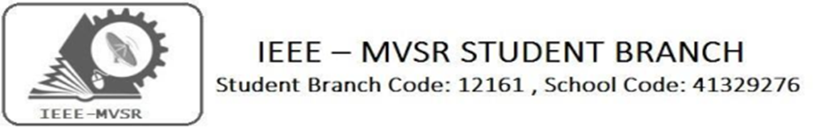

RENEWABLE ENERGY SOURCES - FUTURE PROSPECTS IN INDIA

The Power & Energy Society of IEEE MVSR Student Branch conducted a Lecture on “Renewable Energy Sources - Future Prospects in India”. The main aim of the session is to let the students understand the importance of Renewable Energy Sources, its generation, transmission and future prospects in India.

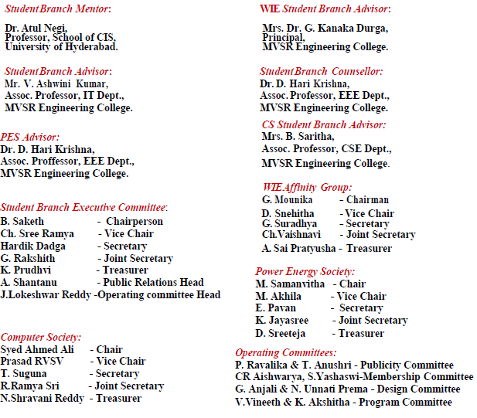

Event details:

Date : 02nd February 2019.
Time : 10:00 am – 12:30 pm.
Venue : QEEE HALL, MVSR Engineering College.

No. of students attended: 70

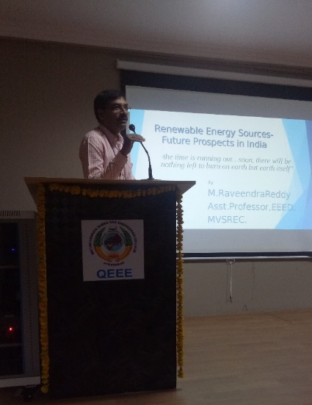
The session was initiated by IEEE MVSR Student Branch Counsellor Dr. D. Hari Krishna addressing the gathering about the importance of IEEE and Power & Energy Society. He has also explained various conducted by the Student Branch and its achievements.
Dr.D. Hari Krishna, IEEE MVSR SB Counsellor addressing the gathering

This was followed by Dr. D.V.M. Chary, Head-EEE Dept. about the importance of Renewable Energy Sources. He also explained the importance of attending such lectures and workshop by IEEE which help the students to explore and enhance their knowledge in latest technologies.

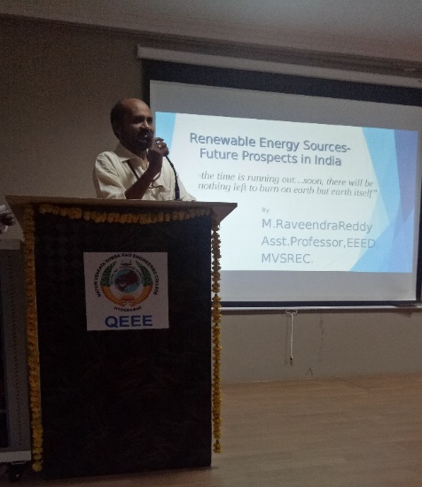
Dr. D.V.M Chary, Head-EEED, addressing the gathering

The session continued by the introduction of the speaker by Mr. I.N. Swamy. The session was handed to the speaker Mr. M. Raveender Reddy who presented the concepts of Renewable Energy Sources, its importance and future prospects in India.
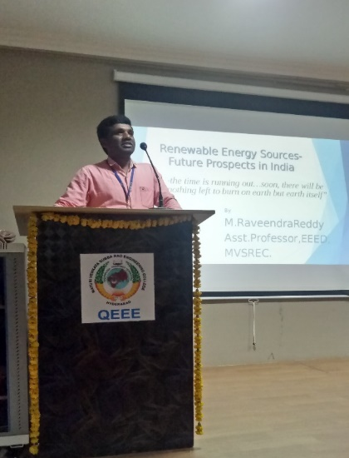
Mr. I.N. Swamy introducing the speaker to the participants

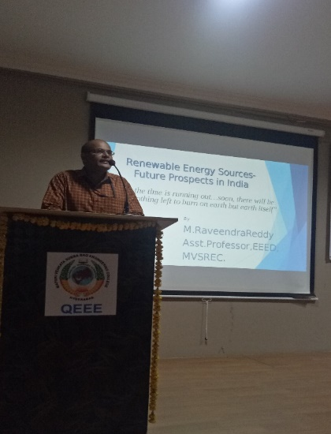
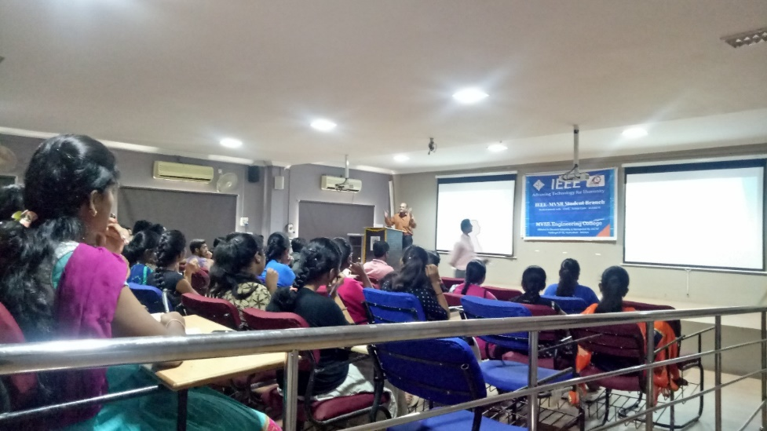
Mr. M. Raveender Reddy delivering his lecture to the students and staff

Mr. Raveender Reddy started with the basic concepts of renewable energy sources. Later he explained the renewable energy in India has recorded tremendous growth over past one and half decades.

This lecture was included with the following topics: Renewable energy and the way ahead, strengthening political economy for clean energy, supporting rural electrification, revisiting the incentives mechanism, Grid integration and management, Alternate sources of energy, Primary commercial energy sources, Solar passive architecture- experiments in Auroville and Constraints in promotion of renewable energy.
All the students and faculty who attended the lecture have learned advanced and up-coming technologies in our day-to- day life related to renewable energy.
The session ended with the vote of thanks by M. Akhila, PES Vice-chair, IEEE MVSR SB.
Reported by
IEEE-SB MVSR.

