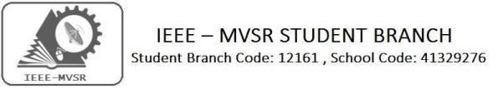
GENERAL BODY MEETING
IEEE MVSR Student Branch had conducted a General body meet on 4th October, 2019. The aim of the meeting was to plan for the upcoming flagship event of IEEE MVSR SB ‘Technovanza’ and discuss the various workshops and events that will be conducted by the respective Student Chapters.

Student Branch Mentor:

Dr. AtulNegi,
Professor, School of CIS,
University of Hyderabad.

Student Branch Advisor:

Mr. V. Ashwini Kumar, Assoc. Professor, IT Dept., MVSR Engineering College.

PES Advisor:
Dr. D. Hari Krishna,
Assoc. Professor, EEE Dept.,
MVSR Engineering College.

Students Branch Executive Committee:

R. Ramya Sree - Chairperson
K. Akshitha - Vice Chair
M. Shreya - Secretary
K. Vinay Kumar - Joint Secretary
V. Vineeth - Treasurer
P. Varun Kumar-Operating committee Head

Computer Society:
S. Sai Teja - Chair
G. Suradhya - Vice Chair
M. VamsiKrishna - Secretary
A. Phani Sahasra - Joint Secretary

V. Manikanta- Treasurer

Circuits and Systems Society:
D.Siddartha -Chair
K.Jaideep -Vice Chair
D.V.B Parthiv -Secretary
D.Venkat -Joint Secretary
P.Shravya -Treasurer
WIE Student Branch Advisor:

Mrs. Dr. G. Kanaka Durga,
Principal,
MVSR Engineering College.

Student Branch Counsellor:

Dr. D. Hari Krishna,
Assoc. Professor, EEE Dept.,
MVSR Engineering College.

CS student branch advisor:
Mrs. B. Saritha
Assoc. Professor, CSE Dept.,
MVSR Engineering College

CASS Student Branch Advisor:
Mrs. S. Aruna
Assoc. Professor, ECE Dept.,

MVSR Engineering College.

WIE Affinity Group:

A. Sai Pratyusha - Chairman
M. Shresta - Vice Chair
Sahithya namani- Secretary

L. Ruthvika- Joint Secretary
R. Ruchitha - Treasurer

Power Energy Society:
E. PavanKumar - Chair
Jayasree k - Vice Chair

N. Avinash - Secretary
B.Nikita Reddy - Joint Secretary

S. Satvika - Treasurer

Operating Committees:
Ch. Jinesh- Publicity Committee
M.V.S.S.S.R Sahith-Membership Committee
Hemish& Y. Sai Sameer - Design Committee

M. Sai Sri Teja- Program Committee
Session details:
Date : 4th October, 2019.
Time : 2:30pm - 4:15pm
Venue: QEEE room, EEE department, MVSR Engineering College.

No. of attendees: 20

Agenda:
- Summary of CS General Body Meeting.
- Summary of PES General Body Meeting.
- Summary of CASS General Body Meeting.
- Summary of WIE General Body Meeting.
- Conclave.
- Technovanza 2K20.
- Utilization of IEEE Community/Networking.
- Magazine and Website.
- AICSSYPC (All India Computer Society Student and Young Professional Congress).
- Awards.
- Problems in Student Branch.
- Augmented Reality and Virtual Reality Workshop.
- Statistical Foundation for Data Science.

The meeting started with R.Ramyasri (IEEE MVSR SB Chairperson) inviting all the Student Chapter Advisors and IEEE Faculty coordinators present, on to the Dias. Dr.D.Hari Krishna (IEEE MVSR SB Counsellor and PES Advisor) discussed the agenda and gave his inputs to the Executive Committee Members regarding the events and workshops.

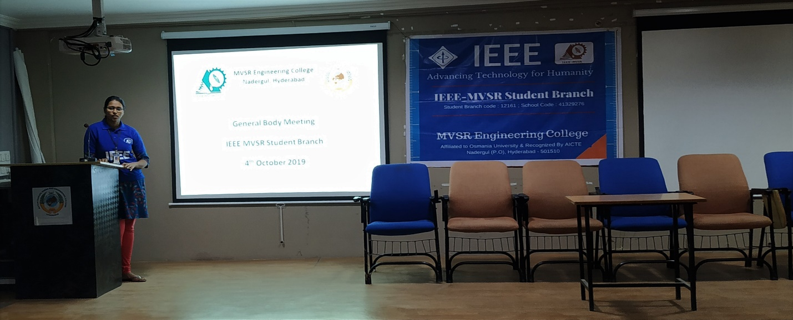
Ramyasri, Student Branch Chairperson addressing the gathering.

Then, all the Student Chapters explained about the outcomes of their individual General Body Meetings, which were held in the last month.
Mr. Varun Kumar (Operating Committee Head), explained that CS Student Chapter had decided to increase IEEE membership by encouraging and interacting with more students, inculcating the present IEEE members with CollabraTec, encouraging them to join SIG’s(Special Interest Group) of their interest, and in participating in the upcoming IEEE Xtreme 13.0 event.

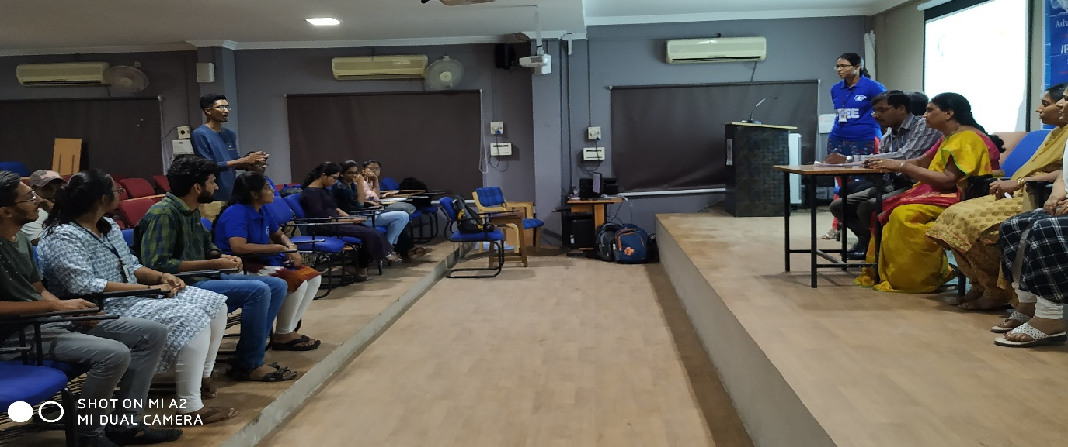
Varun Kumar, Operating Committee Head taking about the CS General Body Meeting.

Mrs. S. Aruna (CASS Student Chapter Advisor), informed about their new proposals for Technovanza, PDP (Professional Development Program) events they would be conducting and about the CollabraTec Mentor and Mentee program were the main topics covered in their General Body Meeting.

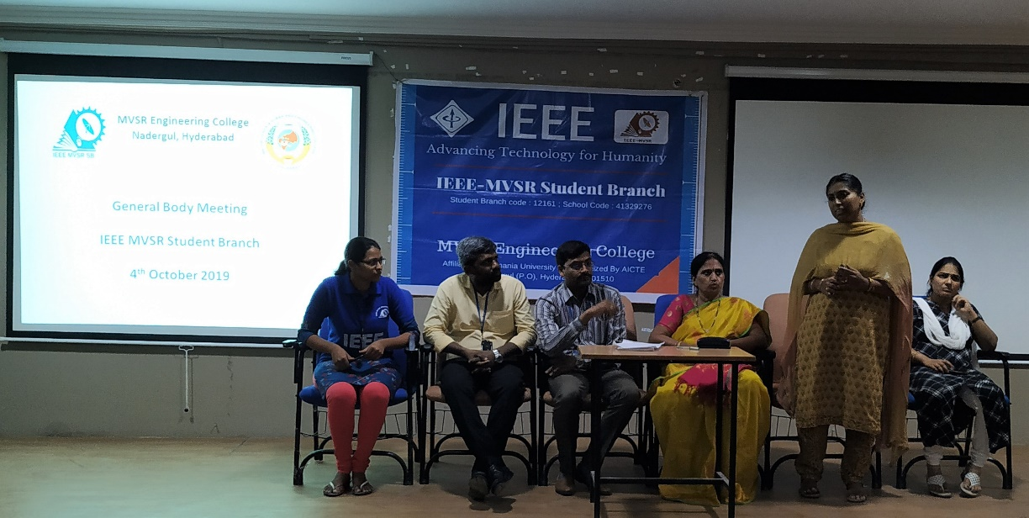
Mrs. Aruna, CASS Advisor talking about CASS General Body Meeting.

Mr. Pavan Kumar (PES Student Chapter Chair), gave a gist about PES General Body Meeting and put forth their ideas for seminars. Miss Pratyusha (WIE Student Chapter Chair), informed about the various social outreach programs like educating women on their rights and personal hygiene, which have been planned for the next semester. All the Faculty Coordinators and Student Chapter Advisors gave their inputs and suggestion for all the ideas put forth.

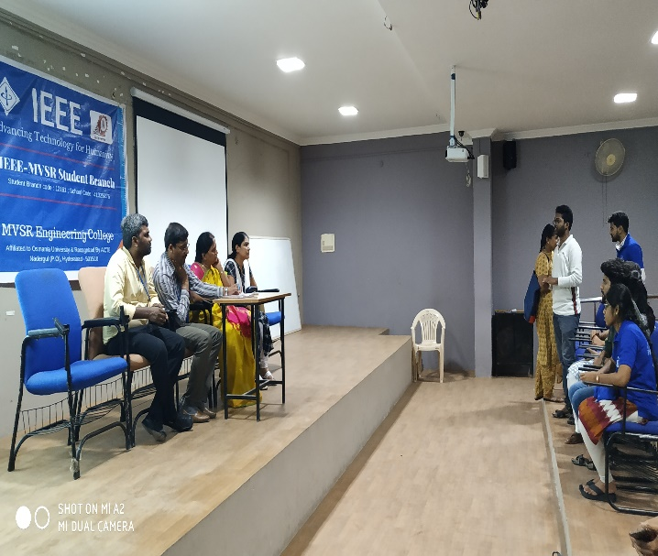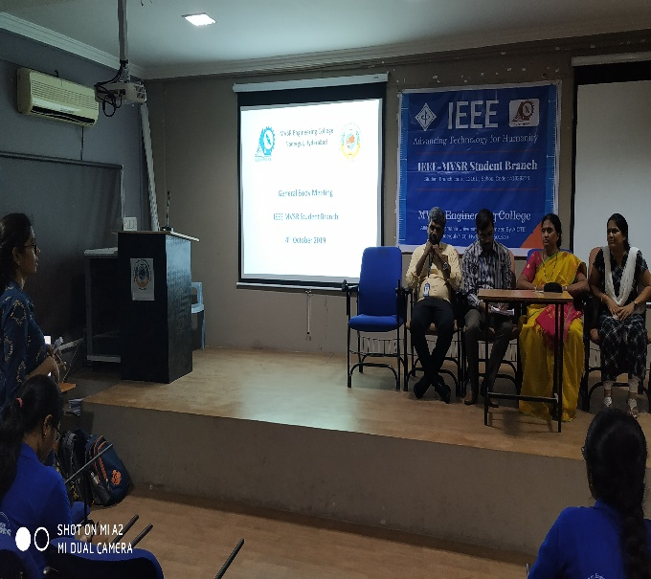
Pavan Kumar, PES Chairperson and Pratyusha, WIE Chairperson Talking about their respective General Body Meeting.

Mrs. Dr.G.Kanaka Durga (WIE Student Chapter Advisor) suggested utilizing the Unath Bharath Abhiyan Program to complete the events planned by WIE. She encouraged everyone to actively participate in the inter-college IEEE events that are being held regularly. Later, planning for Technovanza 2K20 began, sponsorships proposals were discussed. The interim date was announced. Dr.D.Hari Krishna discussed how to utilize the IEEE Section Events in networking, and making new acquaintances.

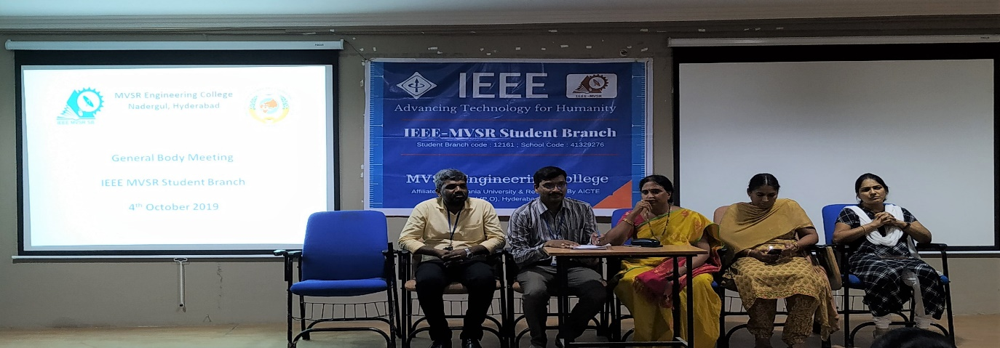
Faculty Coordinators Mr. Swamy (EEED) and Mrs. Vahini (ITD), Student Branch counsellor Dr. D. Harikrishna, Student chapter Advisors Mrs. Dr.G.Kanaka Durga(WIE) and Mrs. Aruna(CASS) giving inputs to students.

Mr. Varun Kumar and Mr. Sai Teja (CS Student Chapter Chairperson), gave a gist on what to be expected in the upcoming workshops by CS Chapter ‘Augmented Reality and Virtual Reality Workshop’ and ‘Statistical Foundation for Data Science’, which will be held in the last week of October 2019.

Mr. Sai Sameer and Mr. Hemish (Design Committee), gave the status of the official website of IEEE MVSR SB and its annual yearly magazine. They were provided with suggestion and inputs to make it more interactive.

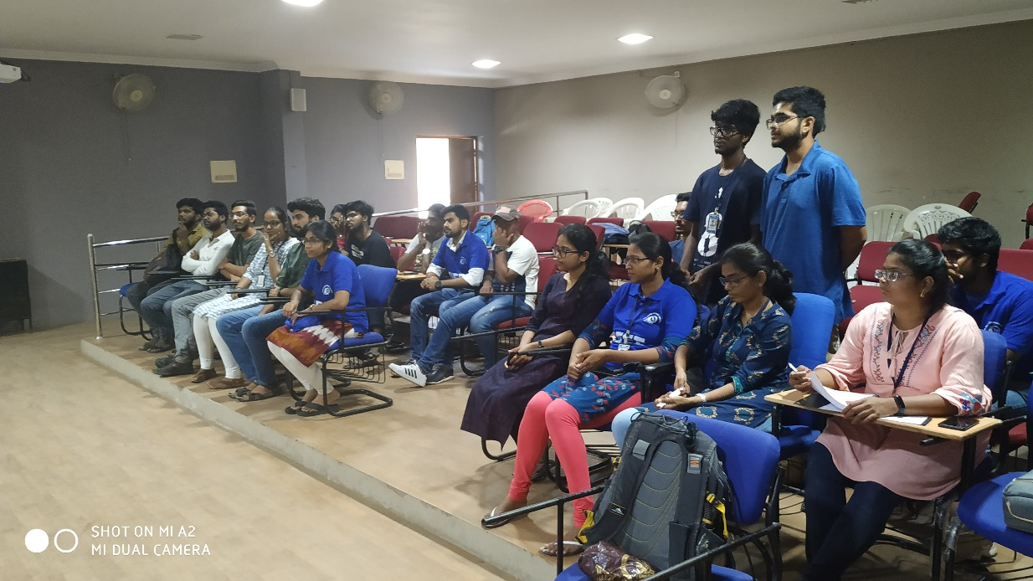
Sai Sameer and Hemish talking about developments in Design Committee.

A discussion was done about the Awards, Scholarships and certificates in IEEE. Eligible members were encouraged to apply for REM (Richard E. Merwin) Scholarship and Upsilon Pi Epsilon Honor Society, which are given by Computer Society. Later, Mr. Ashwini Kumar (Student Branch Advisor), adviced the members to utilize the IEEE platform to try and bridge the gap between a student and skillset required and help them grow in their desired career path.

Miss R.Ramyasri (Student Branch Chairperson) and Mr. Varun Kumar (Operating Committee Head), were applauded for their achievements. Ramya was awarded $22 for MGM and Varun secured 2nd position in the Quiz held by Central University of Karnataka as part of IEEE Day 2019 celebrations. The meeting ended on a good note, with new ideas and enthusiasm to work better.

Reported by:
IEEE MVSR SB.

