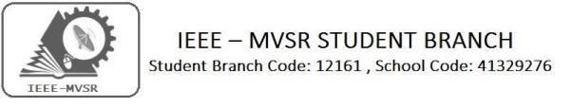

Technical Talk on Energy Harvesting Circuits for IOT Applications

IEEE MVSR Circuits and Systems Society has organized a guest lecture on 07th September 2019. The main motto of the event is to bring an exposure to research perspective in IOT for students.

Student Branch Mentor:

Dr. Atul Negi,
Professor, School of CIS,
University of Hyderabad.

Student Branch Advisor:

Mr. V. Ashwini Kumar, Assoc. Professor, IT Dept., MVSR Engineering College.

PES Advisor:
Dr. D. Hari Krishna,
Assoc. Professor, EEE Dept.,
MVSR Engineering College.

Student Branch Executive Committee:

R. Ramyasri - Chairperson
K. Akshitha - Vice Chair
M. Shreya - Secretary
K. Vinay Kumar - Joint Secretary
V. Vineeth - Treasurer

Computer Society:
S. Sai teja - Chair
G. Suradhya - Vice Chair
M. Vamsi Krishna - Secretary
A. Phani Sahasra - Joint Secretary

V. Manikanta - Treasurer

Circuits and Systems Society:
D.Siddartha -Chair
K.Jaideep -Vice Chair
D.V.B Parthiv -Secretary
D.Venkat -Joint Secretary
P.Shravya -Treasurer
WIE Student Branch Advisor:

Mrs. Dr. G. Kanaka Durga,
Principal,
MVSR Engineering College.

Student Branch Counsellor:

Dr. D. Hari Krishna,
Assoc. Professor, EEE Dept.,
MVSR Engineering College.

CS student branch advisor:
Mrs. B. Saritha
Assoc. Professor, CSE Dept.,
MVSR Engineering College

CASS Student Branch Advisor:
Mrs. S. Aruna
Asst. Professor, ECE Dept.,

MVSR Engineering College.

WIE Affinity Group:

A. Sai Pratyusha - Chairman
M. Shresta - Vice Chair
Sahithya namani - Secretary

L. Ruthvika - Joint Secretary
R. Ruchitha - Treasurer

Power Energy Society:
E. Pavan Kumar - Chair
Jayasree k - Vice Chair

N. Avinash - Secretary
B.Nikita - Joint Secretary

S. Satvika - Treasurer

Operating Committees:
P. Varun kumar-Operating committee Head
Ch. Jinesh - Publicity Committee
M.V.S.S.S.R Sahith -Membership Committee
V.Hemish & Y. Sai sameer - Design Committee

M. Sai Sri Teja - Program Committee

Session details:

Date : 07thSeptember 2019.

Time : 12:30 pm–1:45 pm.
Venue: ECE Seminar Hall, MVSR Engineering College.

No. of IEEE students attended: 15
No. of Non- IEEE Students attended: 35

The session began by our IEEE MVSR SB CASS Chair, D.Sidhartha. He introduced the speaker Dr. Arifuddin Sohel, IEEE CASS/EDS Chapter Chairman,IEEE Hyderabad Section.
The lecture started with a Brief Introduction to IOT. Growth of IOT in past few years.

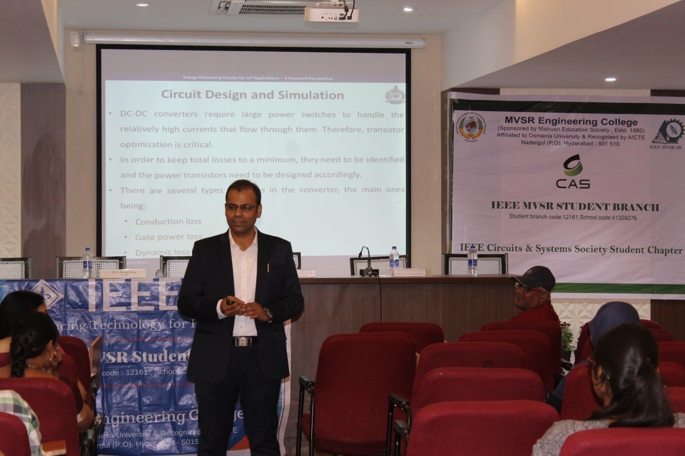
Dr. Arifuddin Sohel Interacting with students.

Then it was followed by giving details about Applications of IOT, Power calculation for IOT devices.

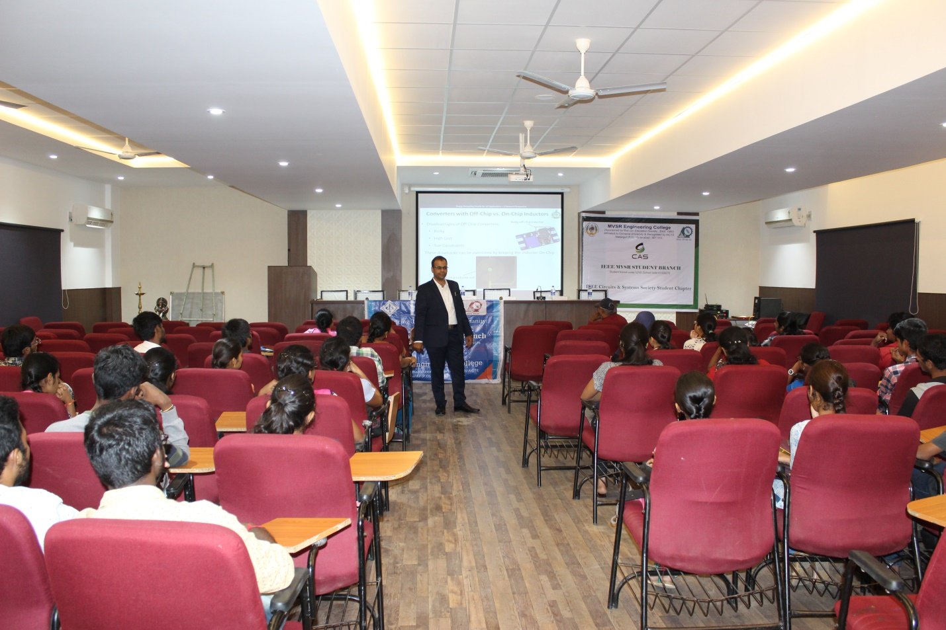
Dr.Arifuddin explaining the topic

The session became more and more interactive when the topic Applications of IOT popped up. Students clarified their queries regarding their further education and subject. Many students gave an active participation.

Later, Energy harvesting, Sources of energy, Energy harvesting system, Transducers, Energy storage devices topics were covered. Using IOT in Energy harvesting system was discussed briefly. It was a very interesting session for students.

Later, Research Perspective-Utopia was discussed. Most of the world’s energy in the future will be generated using Energy harvesting technologies.

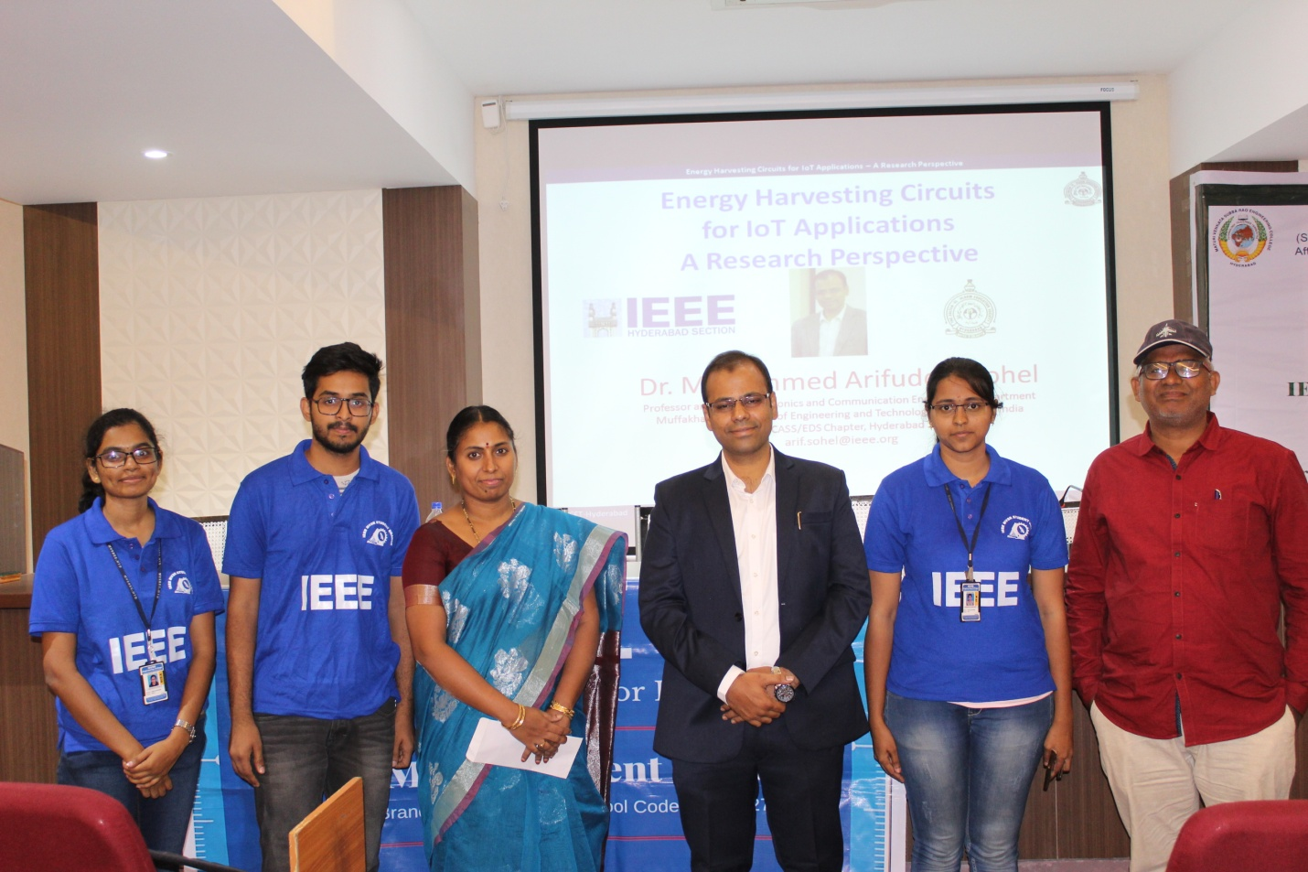
Group Photo with the speaker.

Reported by:
IEEE, MVSR SB.

