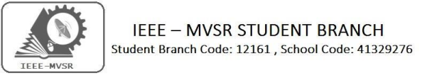
IEEE STUDENT BRANCH OFFICER TRAINING – JULY 2019

MVSR Engineering College IEEE Student Branch had conducted its Officer Training Meet on 04th July 2019. The agenda of the meeting was to introduce the new Executive Committee Members to each other and have a discussion with the Student Branch Counsellor and the Ex-Chair of IEEE MVSR SB [2018-19] regarding the future insights. The main motto was to hand over the duties to the new Executive Committee Members for proper functioning of the Student Branch.

Student Branch Mentor: WIE Student Branch Advisor:

Dr. Atul Negi, Dr. G. Kanaka Durga,
Professor, School of CIS, Principal and Professor,
University of Hyderabad. MVSR Engineering College.
Student Branch Advisor: PES Advisor:
Mr. V. Ashwini Kumar, Dr. D. Hari Krishna,
Assoc. Professor, IT Dept., Assoc. Professor, EEE Dept.,
MVSR Engineering College. MVSR Engineering College.
Student Branch Counsellor:
Dr. D. Hari Krishna,
Assoc. Professor, EEE Dept.,
MVSR Engineering College.

CS Student Branch Advisor:
Mrs. B. Saritha,
Assoc. Professor, CSE Dept.,
MVSR Engineering College.

WIE Affinity Group:
A.Prathyusha - Chairman
M.Shresta Reddy - Vice Chair N.Sahitya - Secretary L.Ruthvika - Joint Secretary
R.Ruchitha Reddy - Treasurer

Student Branch Executive Committee:
R.Ramya Sri
K.Akshitha
Shreya Maqtedar
K.Vinay Kumar
V.Vineeth

- Chairperson
- Vice Chair
- Secretary
- Joint Secretary
- Treasurer

Power Energy Society:
E.Pavan Kumar - Chairman
K.Jaya Sree - Vice Chair
N.Avinash - Secretary
B.Nikitha Reddy - Joint Secretary
S.Satvikka - Treasurer
Computer Society:
S.Sai Teja - Chairman
G.Suradhya - Vice Chair
M.Vamshi Krishna - Secretary
Phani Sahasra - Joint Secretary
V.Manikanta - Treasurer

Operating Committees:
P.Varun Kumar - Operating Committee Head
Ch.Jinesh - Publicity Committee Head
M V S S R Sahith -Membership Committee Head
Sai Sameer & Hemish - Design Committee Head
M.Sai Sri Teja - Program Committee Head

Officer Training Meet Details:

Date: 4th July 2019.
Time : 10:30 am – 01:00 pm.
Venue: CS-13, Dept. Of CSE, MVSR Engineering College.

No. of attendees: 30

The meeting began with an announcement and introduction of all the new office bearers for the year 2019-2020. The meeting continued with addressing of duties of the IEEE Executive Committee by the Student Branch Counsellor Dr. D. Hari Krishna, followed by IEEE CS advisor Mrs. B. Saritha who congratulated the new Ex-Com members.

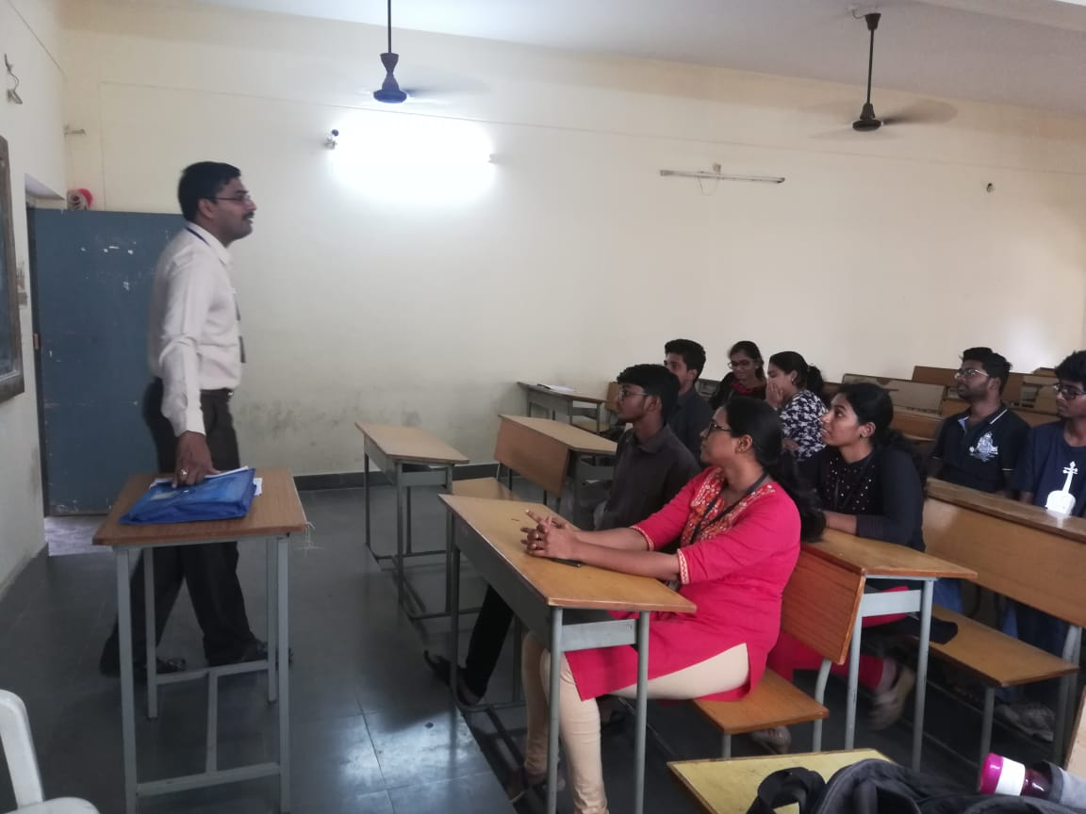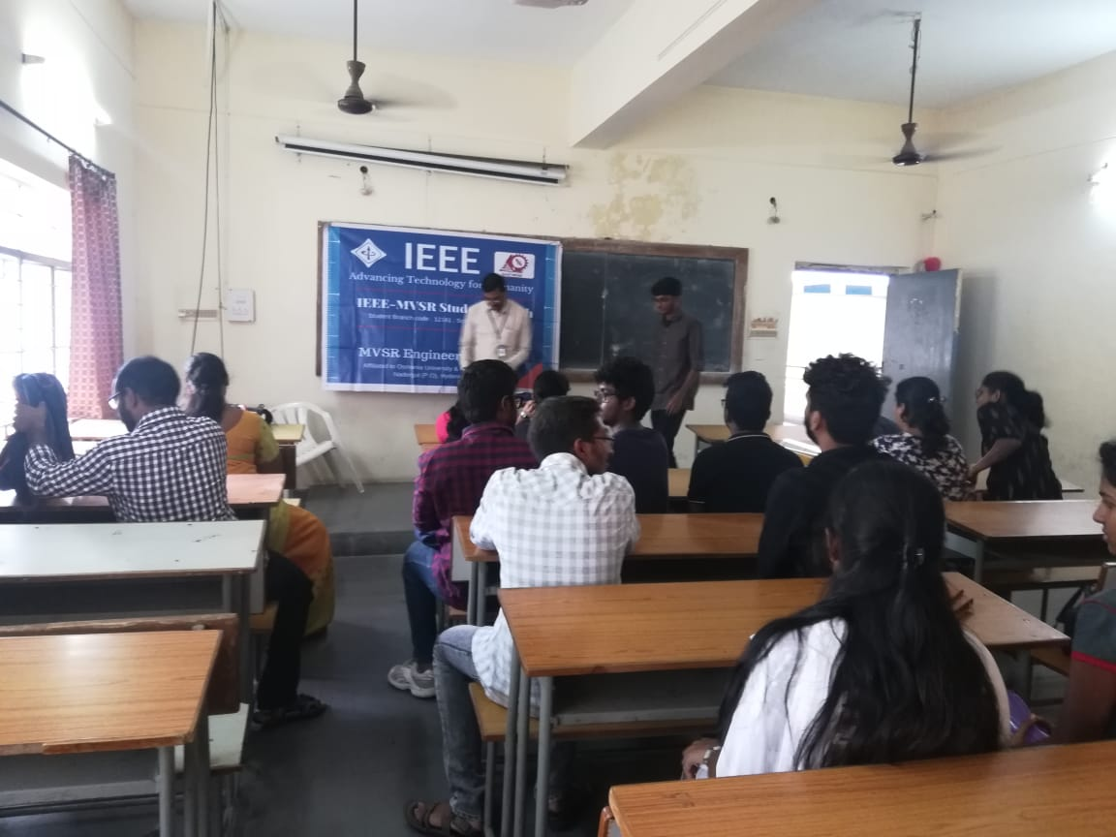
Dr. D. Hari Krishna (Student Branch Counsellor IEEE-MVSR) interacting with the students.
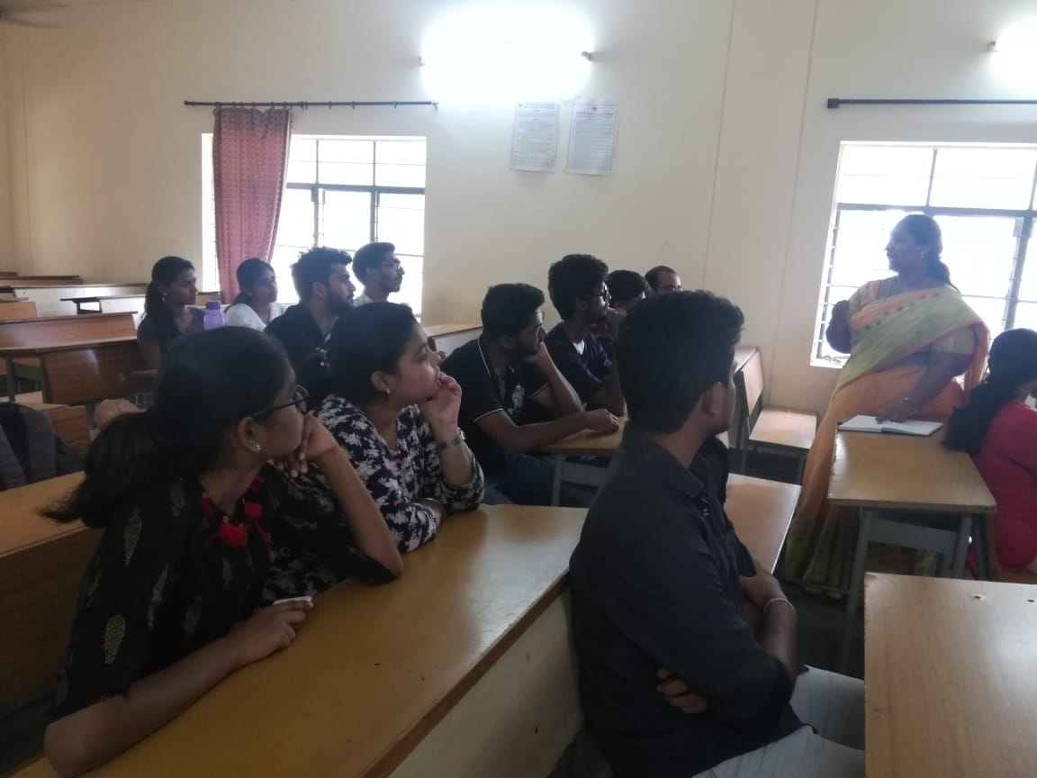-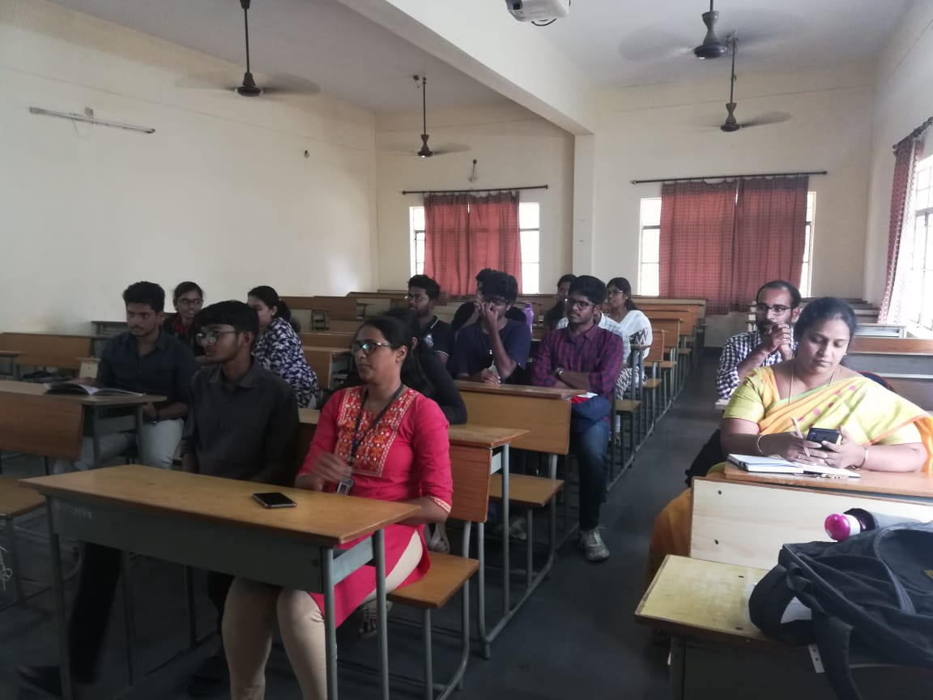
IEEE CS advisor Mrs. B. Saritha, Congratulating the new Executive Committee members.

Later there was discussion involved with few minor plans for the coming months (July, August) and how to work in a united manner for the growth of Student Branch. The Ex-Chair of IEEE MVSR SB (2018-2019), Mr. B. Saketh congratulated the new Ex-Com members and addressed the gathering about the issues and problems which may arise and how to tackled them.

Reported by:
IEEE MVSR SB.

