1. <http://www.ieee.org/index.html> and click on Join IEEE
2. 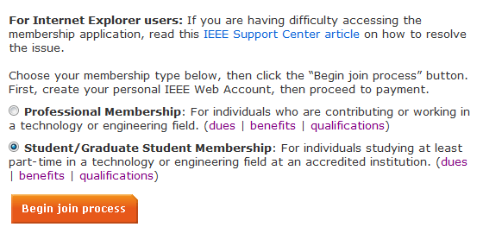Choose student membership and click on the begin join process.
3. Click on join online:

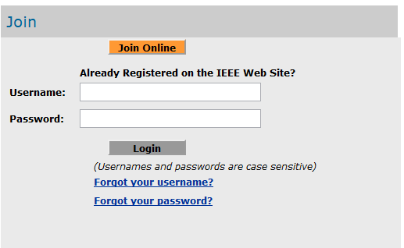

1. 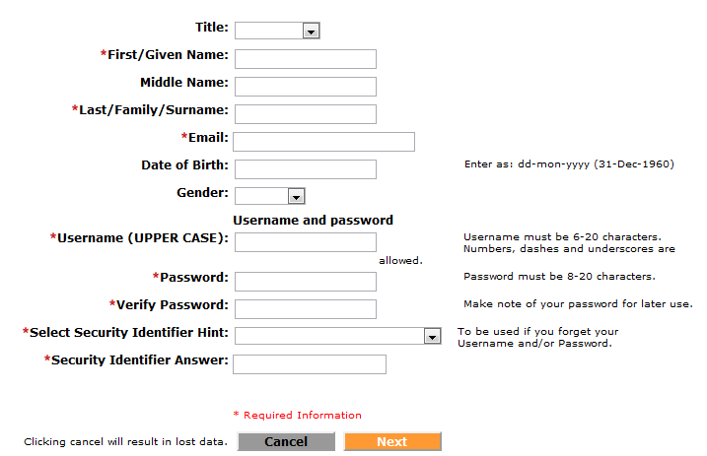Complete the form:
2. After creating your web account (after completing the remaining forms), you can go to My cart and complete the payment process with their credit cards.

For those who have problems with credit cards, or don’t have any, should contact us.