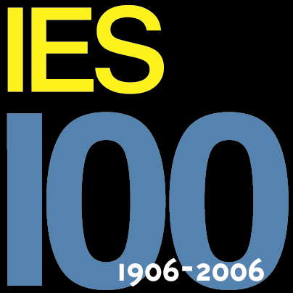 Alamo Section IESNA 
June meeting is 12:00 to 1:00 PM, Thursday the 21st
Theatrical Lighting Controls
Joe’s Crab Shack at The Quarry

Lunch: $12.00
You will have a choice off a select lunch Menu.
The price includes drink (iced tea or water), tip and tax.
Only cash or checks please, Make checks payable to “IESNA Alamo Section.

RSVP: Please RSVP by Tuesday, June 19th, 2007 to Scott Walowsky @ 210-403-5540 scott.walowsky@c-b.com or Stacie Gray @ 210-344-4334, stacie@lonestarltg.com

Speaker: Jeff O’Brien – Genlyte Controls (Lightolier Controls, Entertainment Technology, and Vari*Lite)

Title: Theatrical Lighting Controls for Commercial and Institutional Spaces.

Presentation description: Theatrical Controls have made their way into what use to be standard every day Architectural Applications. Applications, Wiring Practices, Theatrical Standards, and future changes to those standards will be discussed during this presentation.

Bio Info:
Jeff O’Brien
Audio/Video/Lighting Control Integrator 1983-1998.
Regional Sales Manager Automation Controls 1998-2004
Regional Sales Manager Genlyte Controls 2004-Present

The Alamo Section is sponsored in part by:
- Carter & Burgess, Inc.
- HADCO Lighting
- Lone Star Lighting, Inc.
- Sternberg Lighting
- Lightolier

If you are interested in becoming involved in the planning and organization of future Alamo IES functions or if you want to be a section sponsor please contact Scott Walowsky @ 210-494-0088, scott.walowsky@c-b.com.

