GUIDELINE FOR VISUAL IDENTIFICATION
OF DAMAGED POLYMER INSULATORS

November, 1998

Jeff Burnham
Transmission Department
Juno Beach

CONTENTS

Page

PURPOSE 3

POLYMER INSULATOR MAJOR COMPONENT TERMINOLOGY 4

CONDITIONS WHICH DO NOT REQUIRE REPLACEMENT

Chalking 5
Grease leakage 6
Accumulation of dirt 6
Accumulation of mold 7
Hydrophobicity reduction 7
Mechanical damage to a few sheds 8
Low fault current arc damage 8
Arc damage to corona ring 9
Minor corrosion of end fittings 9
De-bonding of sheds 10
Crazing 10

CONDITONS WHICH REQUIRE REPLACEMENT

Damage to the fiberglass rod 11
Exposed fiberglass rod 11
High fault current flashover on suspension insulators 12
Severe corrosion of end fittings 13
Alligatoring 13
Hardware seal failure 13
Significant erosion of surface material 14
Puncture of sheath 14
Overloaded polymer post 15

PURPOSE

The purpose of this document is to provide an easy to use guideline for maintenance personnel to help them determine if a polymer insulator needs to be replaced or not based on its visual appearance. It is a tool to help FPL achieve both low cost and high reliability.

The information and decisions contained in the guideline come from incorporating theory, test data, and the experience of FPL and other utilities. This guideline will require updating as different polymer insulators are added to our system and as polymer aging progresses.

Maintenance personnel are the eyes of the transmission department. Please support this document by providing feedback. For questions or comments concerning the contents of this guideline please contact the Transmission Department.

POLYMER INSULATOR MAJOR COMPONENT TERMINONLOGY

Fiberglass rod: The fiberglass rod is the internal strength member of the polymer insulator. It must never be exposed.

Polymer rubber: The polymer insulators used by FPL have had material composed of silicone rubber, ethylene propylene rubber (EPR), or an "alloy" (EPR with silicone oils added). The sheds and sheath are made of polymer rubber. Test results and experience have shown that silicone rubbers generally perform much better than EPR in contamination. We use only silicone within 1 mile of saltwater bodies.

Shed: The sheds are the discs or skirts on the insulator. They may be flat, concave or cone shaped. Sometimes they are installed with alternating diameters. The shed function is to increase contamination performance of the insulator.

Sheath: The sheath is the covering for the rod. Its primary function is to keep water out of the rod and protect it from ultraviolet Radiation (UV)

End fittings: End fittings have the mechanical function of transferring mechanical load from the fiberglass rod to the structure, and the fiberglass rod to the conductor. They are generally galvanized steel, but sometimes aluminum is used.

End fitting seal: At the junction of end fitting at the polymer rubber there must be a tight seal to keep water out. In most insulators a silicone sealant is applied after the insulator is manufactured.

Anchor: The anchor is the metal part compressed onto the rod of a post insulator. The anchor is then bolted onto the base plate.

Base plate: Sometime just called the "base", the base plate attaches the line post insulator to the structure.

Corona ring: The purpose of corona rings is to reduce the electrical field stress at the end fittings. They are required at the line end of all 230KV suspension insulators and at both ends of all 500KV polymer suspension insulators. Corona rings are designed for each manufacturer insulators. They are not inter-changeable.

CONDITIONS WHICH DO NOT REQUIRE REPLACEMENT

There are a variety of conditions that may be visually seen on in-service insulators that are not seen on new insulators but are unlikely to represent a reliability risk. These conditions do not normally require the insulator to be replaced.

Chalking

Chalking is created as the result of ultraviolet radiation (UV) and/or electrical activity causing superficial damage to the polymer rubber. All polymer rubbers contain a high percentage of what is called "filler". When a small amount of the rubber on the surface is removed by UV or arcing the filler material is left. It is almost like the bones of a decomposing animal. The removal of rubber is usually limited to just a small fraction of the thickness of the rubber and therefore is no cause for concern. The filler gives the insulator a chalky appearance. It is a white powdery substance. Chalking occurs mainly on a type of polymer called EPR (not silicone)

Although chalking itself is not harmful, it does allow more accumulation of contamination and water on the insulator surface than un-chalked surfaces. Insulators prone to chalking are not approved for use in salt areas. If found in such places they should be removed.

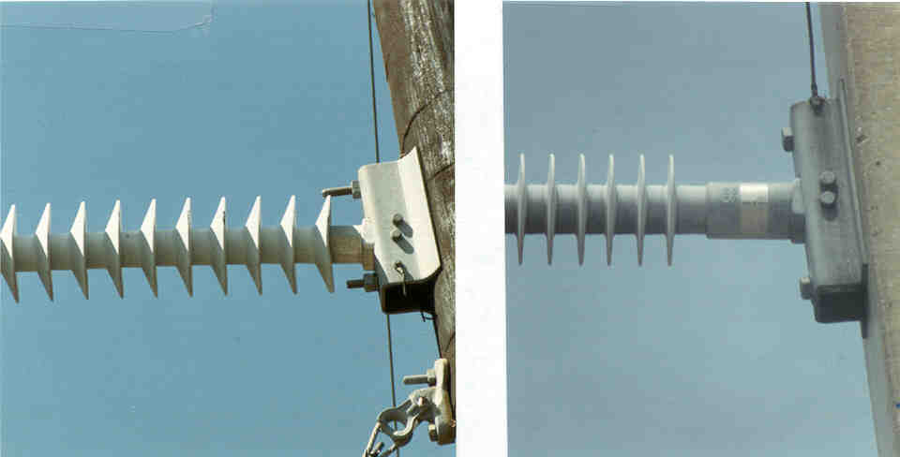

A chalked poly insulator A chalked poly insulator

Grease Leakage

Each manufacturer has its unique way of making insulators. In the design used by one manufacturer, silicone grease is put under mild pressure between the fiberglass rod and the rubber housing. It is normal, and not harmful, for some of the grease to come out at joints. The silicone grease, being sticky usually becomes very black due to mold and dirt accumulation.

If the grease is leaking out in an area with no joint it may be a sign that the insulator was gunshot, or damaged in some other way, in which case it should be replaced.
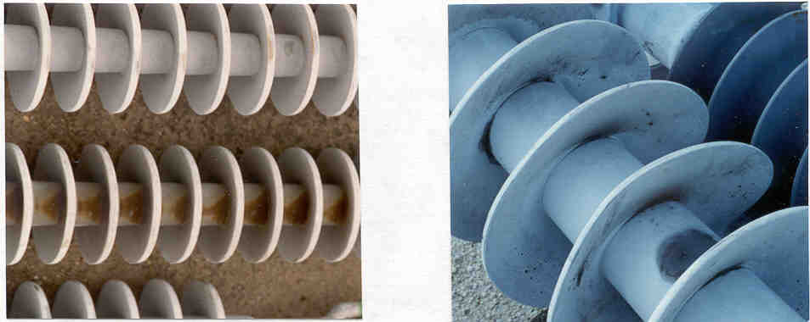
Grease leaking out of joints of poly Post Grease leaking out of joints and gunshot area

Accumulation of dirt

All insulators can get dirty. The dirt does not cause harm to the rubber and does not require the insulator to be replaced. If it is so thick, especially in the case of salt, that it may cause a flashover then the insulator should be washed.

Silicone insulators can become very dirty without the danger of flashover. 230KV and 500KV silicone insulators tend to get very dirty at the line end due to the strong electric field.

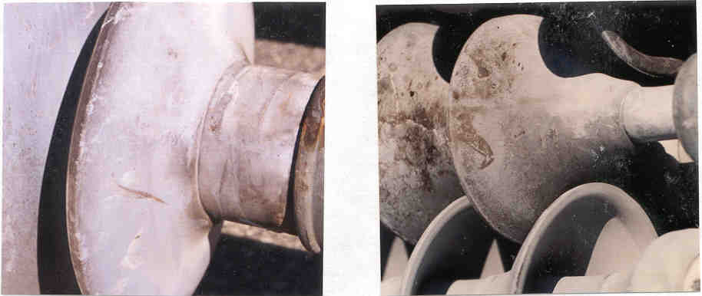
Dirt on a silicone post Dirt on a EPR suspension
Accumulation of mold

Silicone insulators can sustain mold and algae growth. Tests have shown this can reduce contamination performance. Fortunately, mold and algae growth does not seem to occur near salt exposed areas, where the contamination performance of silicone is most needed. FPL has not had a known flashover due to mold or algae growth on a polymer insulator.

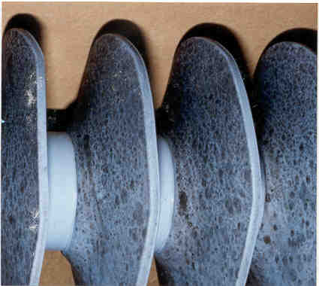

Mold on a silicone post

Hydrophobicity reduction

Hydrophobicity is the ability of a surface to bead water. The loss of hydrophobicity on an insulator surface normally does not mean it should be replaced. EPR insulators with heavy chalking have lost all hydrophobicity. A guideline for classifying hydrophobicity using pictorial representations is available from Transmission Design if required.

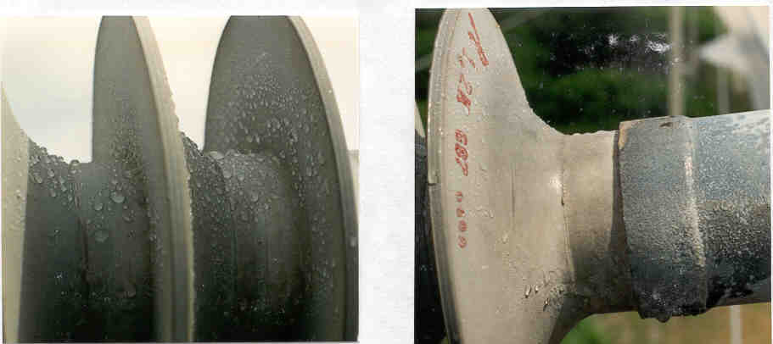

High Hydrophobicity Low Hydrophobicity

Mechanical Damage to a few sheds

Insulator sheds may be ripped, cut, abraded, or punctured by handling, or gunshots. The purpose of insulator sheds is primarily preventing contamination outages. The loss of several sheds due to mechanical damage should not cause a problem and is not cause for removal.

Although the above is true, any insulator that has been damaged should not be installed.

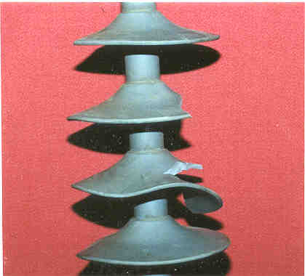
Ripped sheds on a poly suspension

Low fault current arc damage

Low current flashover damage to suspension and post insulators causes only minor damage to line end fittings. The rubber is not harmed. These insulators can be left in service and removed after inspection reveals heavy corrosion due to removal of the galvanized layer.

There have been a few instances where the polymer insulator has a puncture and flashed internally. This seriously hurts the rubber and sometimes the rod. In all cases to date, this has resulted in a lockout and so the insulator has to be replaced to restore the line.
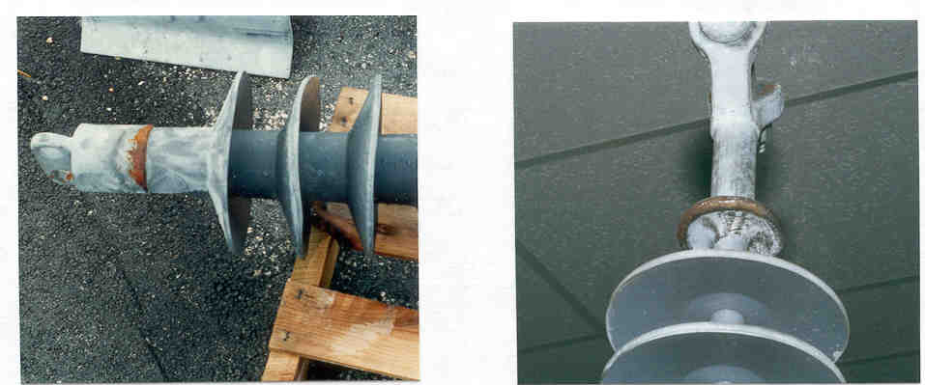

Low fault current damage to poly post Low fault current damage to poly suspension
Arc damage to Corona ring

Arc damage to the corona ring is harmless unless the ring has been loosened or knocked off the insulator. In such cases, simply replace the ring but not the insulator.

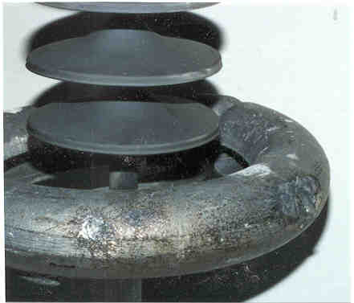

Arc damage to 230KV corona ring

Minor Corrosion of end-fittings

Minor corrosion of polymer insulator end-fittings is not cause for insulator replacement. However, it is understood that with time the corrosion will become worse and ultimately require replacement.

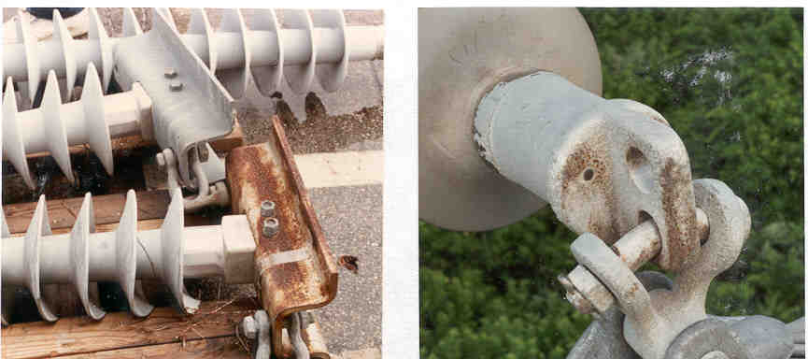

Minor corrosion of poly post base Minor corrosion of poly suspension fitting

De-bonding of sheds

Due to a unique manufacturing process and poor quality control in 1990 the sheds of one manufacturer’s insulators were found to be loosely applied. The shed could be ripped off the rod relatively easily. This problem was identified and remedied by the manufacturer. There are some insulators in-service with this feature. There have not been any failures due to this, and the insulators need not be replaced.

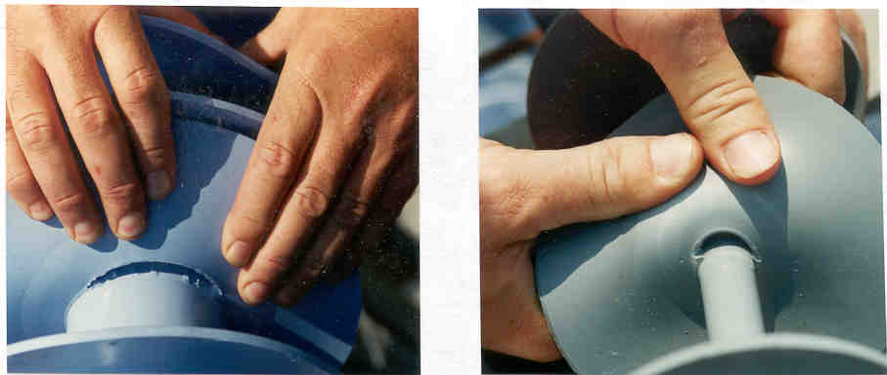

De-bonded poly post De-bonded poly suspension

Crazing (surface micro-fractures of depths less than 0.1 mm)

Crazing results in very shallow fractures of the insulator surface, usually due to electrical activity. Crazed insulators do not necessarily require replacement but they should be monitored as the crazing may become worse and develop into a more serious condition.

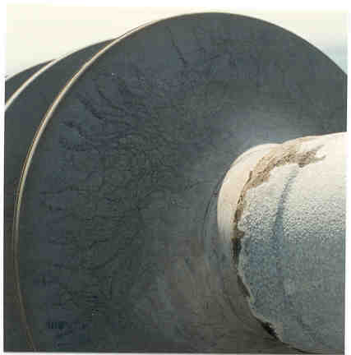

Crazed insulator surface

CONDITONS WHICH REQUIRE REPLACEMENT OF POLYMER INSULATORS

Sometimes an insulator is damaged in such a way, or to such a degree, that leaving it in service presents an unacceptable reliability risk and it must be removed

Damage to the fiberglass rod

If a poly post or suspension insulator is found that has fiberglass strands that are, or may be damaged, the insulator is to be replaced. Such damage may result from gunfire or handling damage.

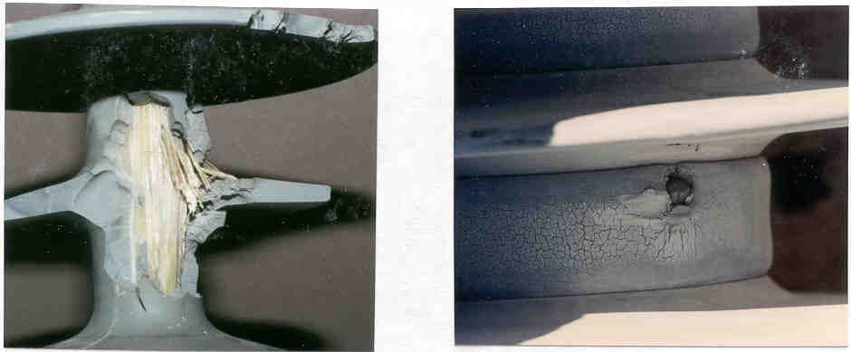

Gunshot damaged fiberglass rod Bullet Lodged in poly post

Exposed fiberglass rod

There are numerous causes of an exposed fiberglass rod including: erosion or cracking of outer covering, splitting or cutting of sheath, tracking of sheath, handling damage to outer covering, and gunshot damage to sheath. An exposed rod may become damaged due to water intrusion, UV degradation, and tracking which can result in a failure.

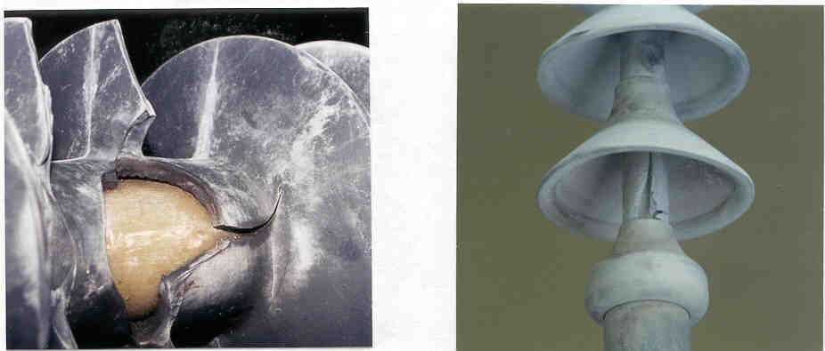
Fiberglass rod exposed by handling damage Fiberglass rod exposed by tracking
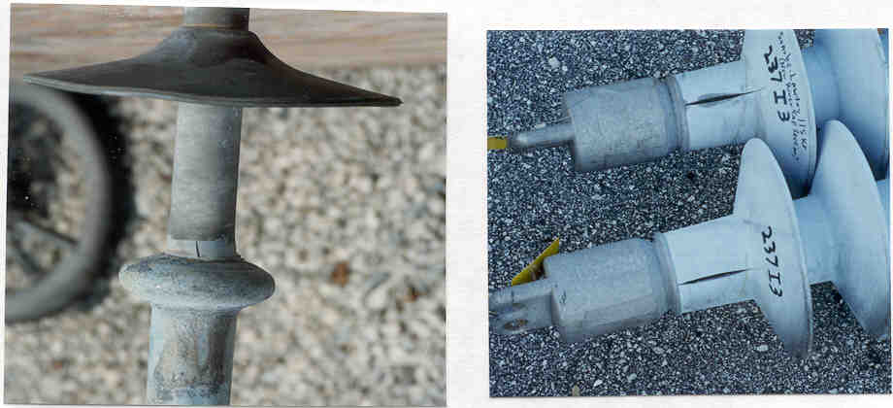

Fiberglass rod exposed by split covering Fiberglass rod exposed by split covering

High fault current flashovers on suspension insulators

High fault current flashovers on a suspension insulator may result in damage to the ball and socket joint resulting in loss of strength, which may be exacerbated by corrosion. If the ball and socket is already corroded the damage can be immediate due to high resistance contact surfaces.

Any polymer suspension insulator with an arc that punctures the corona ring be replaced.

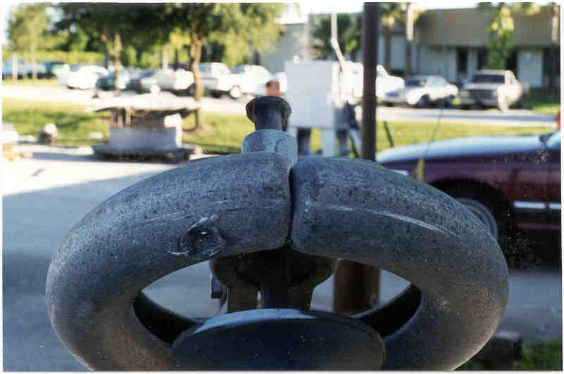

High current flashover on a suspension poly

Severe corrosion of end fittings

Polymer insulators are prone to mechanical failure, as are porcelain insulators, if the hardware becomes so corroded that it cannot hold the mechanical load. When polymer insulators are found in this condition they are to be removed. FPL has not had this type of failure yet, nor have heavily corroded polymers been identified due to their relatively short in service time.

Alligatoring: progression of crazing to depths greater than 0.1 mm

Probably resulting from a progression of crazing, alligatoring reduces contamination performance and may lead to rod exposure.

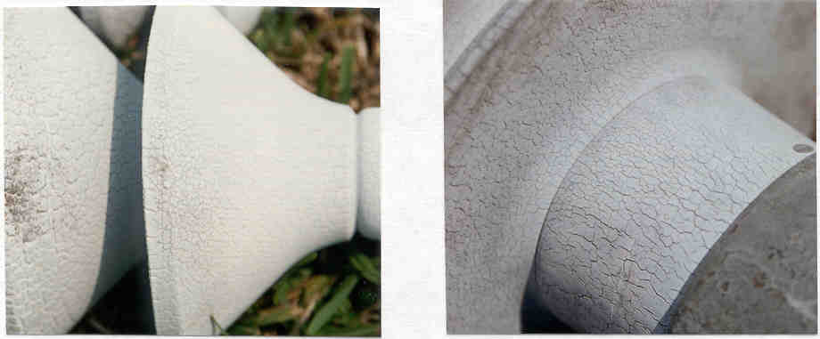
Alligatored poly suspension Alligatored poly post

Hardware seal failure

Hardware seal failure may result from arc damage, corona damage, erosions, poor seal application by the manufacturer, or poor seal material. A poor seal may glass result in a brittle fracture or puncture. A poor seal may be characterized by presence of rust in the seal area.

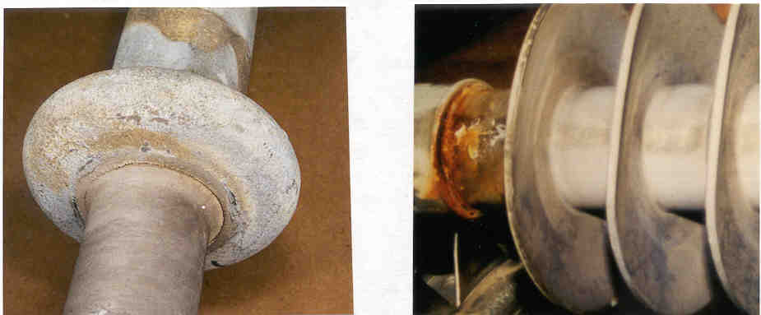
Poor seal on a 500KV poly Poor seal on a 230KV poly post
Significant erosion of surface material

Erosion is an irreversible and non-conductive degradation of the surface of the insulator that occurs by loss of material. It may result in rod exposure

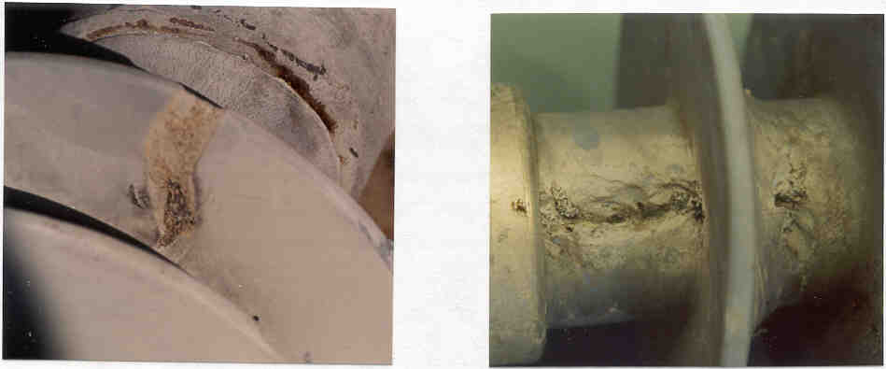

Erosion of poly post shed Erosion of poly post sheath

Puncture (worm hole) of sheath

Puncture results from a disruptive electrical discharge occurring through the rubber, or rod, causing permanent loss of electrical strength. It may have resulted from an imperfection in the rubber or rod.

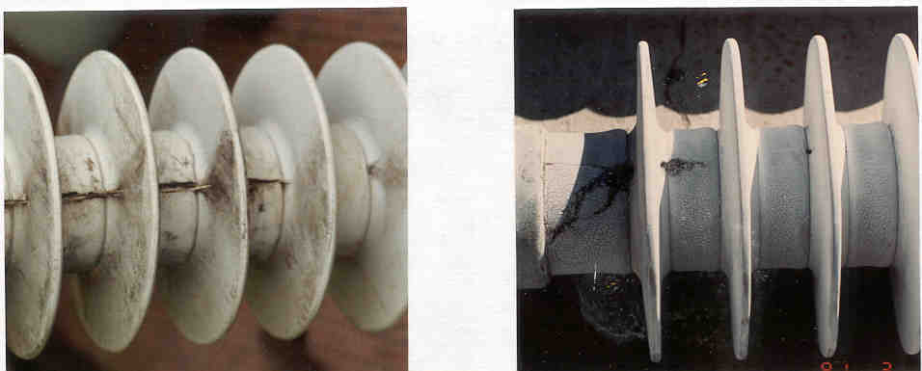

Punctured (split) rod Punctured sheds

Overloaded polymer Post

Overloaded polymer posts may break months or years after installation. A delay in breaking is because individual glass fibers in the rod are not loaded equally. The most loaded fibers part first transferring additional load to intact fibers, until some of them part, and so on, until failure.

To enable engineers to predict conductor clearance to ground, for esthetics, and as a visual check for proper application; a polymer post loading criterion has been established. "At maximum FPL useful cantilever rating, the conductor hardware attachment hole (the lower hole of the 2 hole blade) shall be at, or above, a line, normal to gravity, drawn from the middle of the insulator base." If a post insulator is installed and the attachment hole is below the line, the engineer is to be contacted immediately as the insulator may be overloaded.

There are installations that do not meet the above criterion but are loaded below rating:
1. Corbett - Jog 230KV (first installation of un-braced 230KV posts)
2. Midway - Turnpike (insulator unloaded deflection angle not to FPL specifications)
3. Poly posts on wood poles may appear drooped due to the base plate digging into wood.

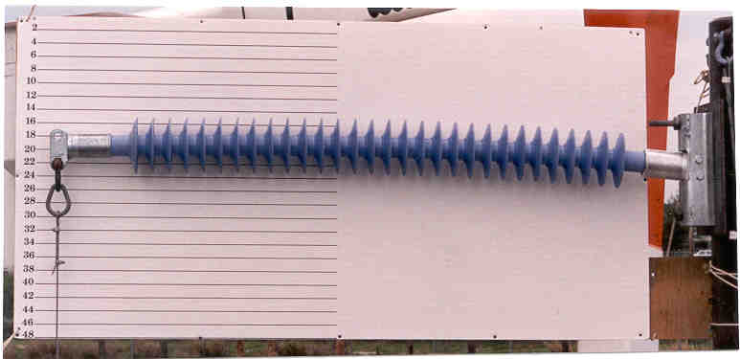

230KV post at maximum rated load
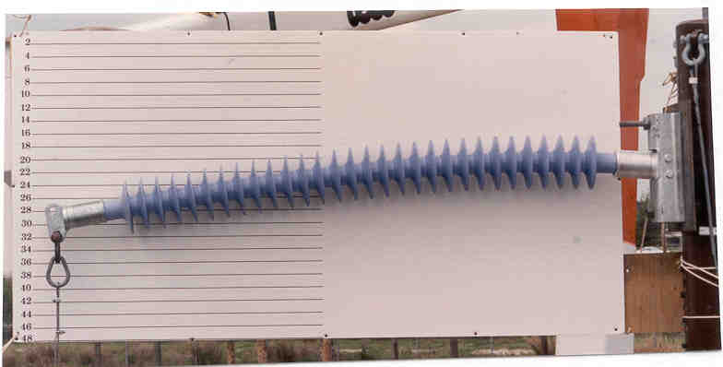
230KV post exceeding maximum rated load

