How to reach Fukuda Lab., Nagoya University
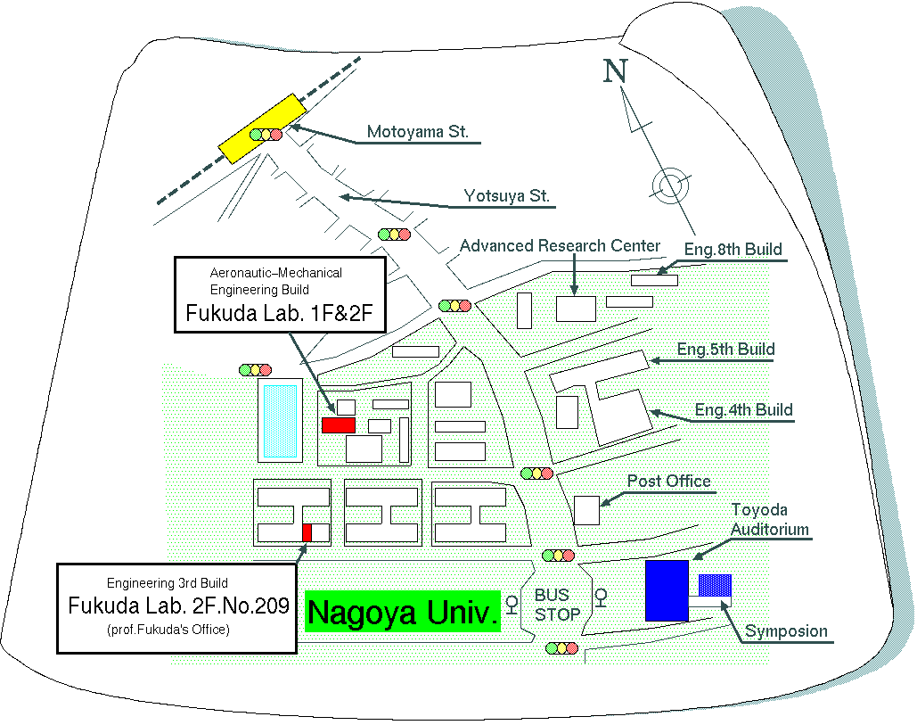
If you arrived NAGOYA Station., take the subway called HIGASHIYAMA line. You should get down at MOTOYAMA Station. And you should go along YOTSUYA Street in direction of south about 15 min. If you can ride on a bus, please get down at "in front of NAGOYA Univ." stop. Main-laboratory is in the first and second floor of Aeronautic-Mechanical Engineering building.
Place to meet to attend laboratory tour
on 10:10 Sep. 12 (WED), 2001

