- You can edit your title and name in the red box of file(.doc).
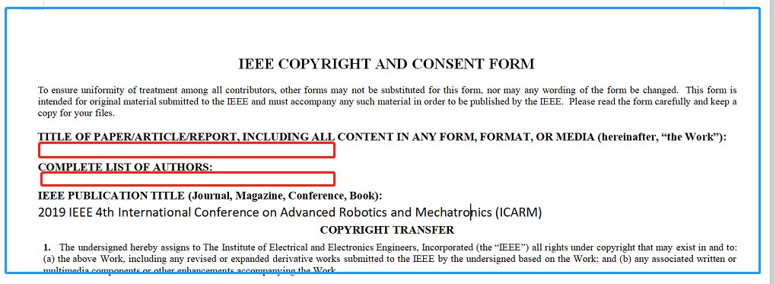
- Print the file.
- Sign your manuscript name and date in the red box.
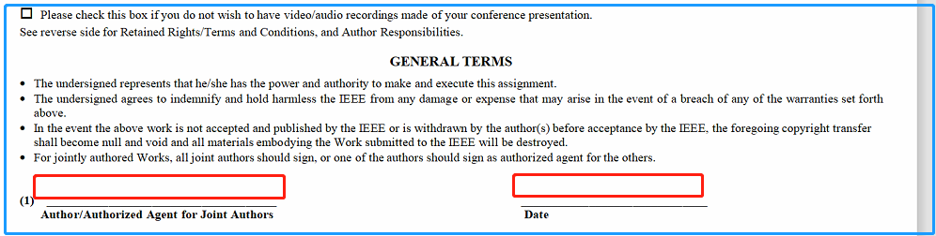
- Scan this signed files into PDF version and upload it to the submission system.
Url: http://ras.papercept.net/conferences/scripts/start.pl

