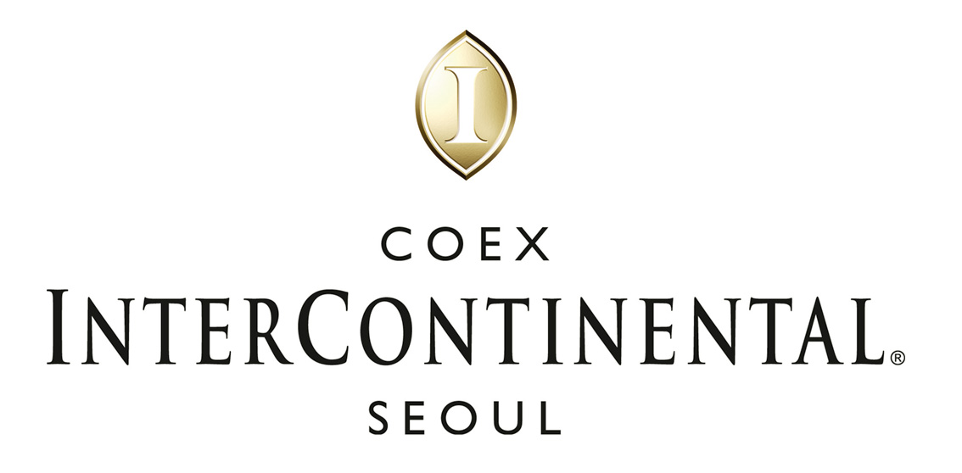

HOTEL RESERVATION REQUEST
Reservation Dept. : Phone: 82-2-559-7777
Fax: 82-2-559-7896, email: : reservation@icseoul.co.kr

Special rate for participants of
ICCAS 2007 Oct 17 – Oct 20 , 2007

Last Name (Mr./Ms.) First & Middle Name
Company Name
Address
City State Zip
Phone No. Fax No.
E-Mail : Sharing Room with :
Arrival Date (Flt No./Time )
Departure Date (Flt No./Time )

♦Please return this form to reservation office directly by fax or E-mail no later than September18 ,2007 to ensure room availability and special discount .
♦Please, circle your choice of accommodations:

COEX InterContinental Seoul: Superior Room(Single occupancy) KRW 220,000
Superior Room(Double occupancy) KRW240,000
- The above rates are breakfast exclusive, room only.
- Breakfast Buffet special rate will be available at KRW 22,000 plus 21% of Tax and Service charge.
- The above rates are subject to 21% service charge & tax.
- Above rates are subject to 10% service charge & cumulative 10% tax (For foreign guests, zero tax will be imposed on room rate when charges are paid by themselves.) effective July 1, 2007 through December 31, 2008.
- Check-in time - 3:00 PM, Check-out time - 12:00 noon.
- Each reservation should be accompanied with a one-night deposit (use major credit cards: (□Amex □Diners □Master □Visa □JCB).
Card Number: ____________________________( 4 digit # for AMEX: _ _ _ _ )
Expiration Date :
- One night room payment inclusive of tax and service charge in case of no-show or late cancellation made 7 days prior to check-in.
♦Please indicate special requests and comments;

Date : Signature :

