Paper abstract Registration
No. 01----Personal information
Register’s full name  Position  ○PROF ○ASSOC.PROF ○ASSIT.PROF ○DR.PROF ○MISTER ○MISS  Affiliation |  | ONE-INCH  PHOTO
Contact E-mail | Contact Number | ONE-INCH  PHOTO
No. 02----Paper information
Paper ID
Paper Title
Paper Authors
No. 03----Conference information
Option A-----Oral Presentation
Must attend the conference and need to prepare a Power Point for your paper in 15 minutes (Including A&Q)
Catering
It is free for participants of ICCRE2020 to join the items below. If you will join in, please mark it.
Lunch during the conference day, Osaka, Japan--------------Yes □ / No □
Dinner Banquet the conference day, Osaka, Japan -----------Yes □ / No □
Special Dietary
VEGETARIAN □ MUSLIM □ OTHER □ (PLEASE SPECIFY: )
Invoice Title
Taxpayer's Registration Number (Only for People/Organization from mainland China):

Please provide the details of your address to make sure you receive the materials.
Received by Telephone Number
Detailed Address Information
No. 04----Oral Presenter Registration
Please mark the corresponding option in red.
At least one author for each accepted final paper must pre-register. On-site payment cannot be permitted.
The paper abstract registration fees are including: coffee breaks, lunch and dinner on the conference day on April 25, 2020, certificate, souvenir for participant.
Before Jan. 10th, 2020
Oral Presentation Only | 350 USD
Extra Proceeding | 80 USD / One Proceeding

No. 05----Payment Ways
Online Payment
http://confsys.iconf.org/online-payment/18131 (No Handing Fee)
Confirmation Email | Confirmation Order Number
Paypal Information
Conference Recipient Account pay@academic.net（Need to pay extra 30USD handing fee）
Payment Account Name |  | Payment Email
Confirmation Order No. |  | Payment Date
- Accepted abstract will not be published by ICCRE2020.
- After you finish the registration form, please send it to iccre2017@yeah.net with Papers Abstract (doc & .pdf) and Payment Proof.
- The conference site is public, all your belongings shall be taken with you all along in case of any unpleasant loss. If unfortunately, we assume to no responsibility for the loss;
- ICCRE is not responsible for problems beyond our control such as weather conditions, campus conditions, visa problems, health issues, financial default, criminal damage, riots or civil strife, industrial action, natural or nuclear disaster, war or threat of war, actual or threatened terrorist activity, epidemic etc. No refunds will be given if these situations occur;
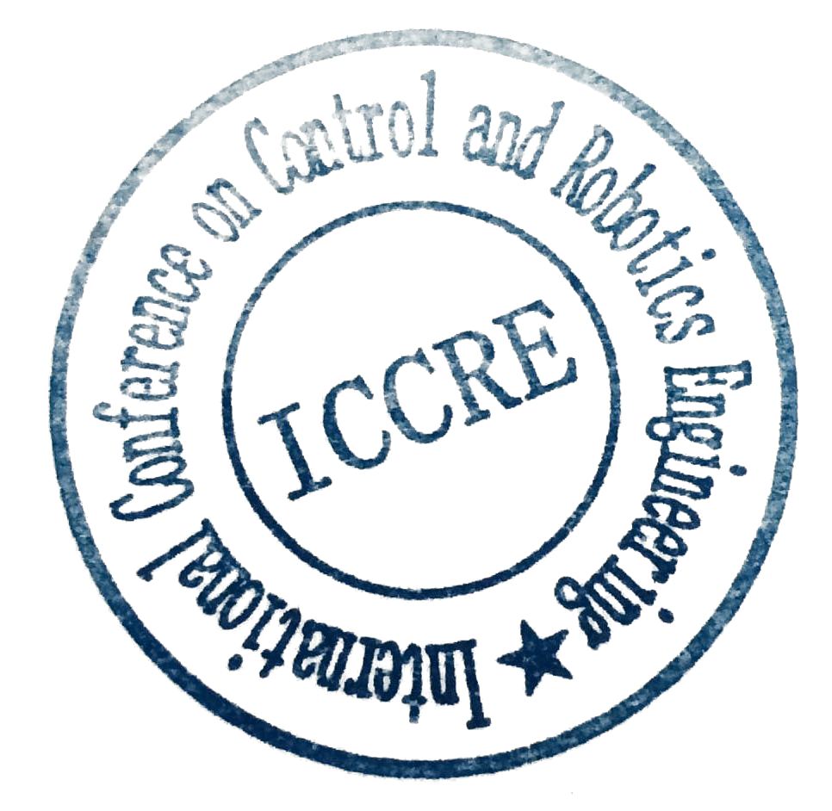
- The organizer has the right to change the date and place of the conference under the reason of circumstances such as weather damage, criminal damage, riots or civil strife, industrial action, natural or nuclear disaster, adverse weather conditions, war or threat of war, actual or threatened terrorist activity, epidemic etc. The participants of the conference are obliged to cooperate with the organizer's change and refund policy.

ICCRE Conference Committee
Osaka, Japan

